Question # 1

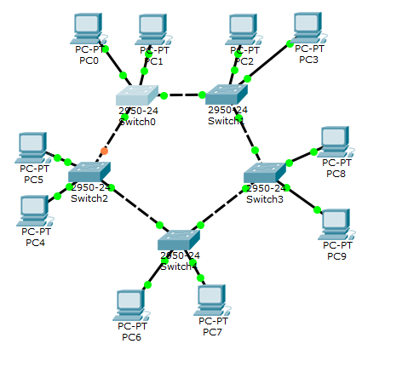

Part a)

Switch(config)#hostname umar

umar(config)#

part b)

umar(config)#line console 0

umar(config-line)#password umar

umar(config-line)#login

User Access Verification

Password:

umar>

part c)

umar(config)#enable password cisco

part d)

umar(config)#enable secret umar

part e)

umar#copy running-config startup-config

Destination filename [startup-config]?

Building configuration...

[OK]

QUESTION # 2

1. **CLS**

CLS (for clear screen) is a command used by the **command line interpreters COMMAND.COM** and **CMD.EXE** on DOS, OS/2 and Microsoft Windows operating systems to clear the screen or **console window** of commands and any output generated by them

1. **Tracert**

TRACERT (Trace Route), a command-line utility that you can use to trace the path that an Internet Protocol (IP) packet takes to its destination

1. **IPCONFIG**

Displays all current TCP/IP network configuration values and refreshes Dynamic Host Configuration Protocol (DHCP) and Domain Name System (DNS) settings. Used without parameters, **ipconfig** displays the IP address, subnet mask, and default gateway for all adapters.

1. **Ipconfig/all**

**/all :**Displays the full TCP/IP configuration for all adapters. Without this parameter, **ipconfig** displays only the IP address, subnet mask, and default gateway values for each adapter. Adapters can represent physical interfaces, such as installed network adapters, or logical interfaces, such as dial-up connections.

1. **Ping 127.0.0.1**

**Ping** is a [computer network](https://en.wikipedia.org/wiki/Computer_network) administration [software utility](https://en.wikipedia.org/wiki/Utility_software) used to test the reachability of a [host](https://en.wikipedia.org/wiki/Host_(network)) on an [Internet Protocol](https://en.wikipedia.org/wiki/Internet_Protocol) (IP) network. It measures the [round-trip time](https://en.wikipedia.org/wiki/Round-trip_time) for messages sent from the originating host to a destination computer that are echoed back to the source

1. **Ping –n 2 10.0.0.1**

Specifies numeric output only. No attempt is made to look up symbolic names for host addresses.

1. Ping –l 64 10.0.0.1

|  |  |
| --- | --- |
| **-l***Preload* | Sends the number of packets specified by the *Preload* variable as fast as possible before falling into normal mode of behavior (one per second). The **-l** flag is a lowercase l. |